########################################Checkpoint 7.1##############################

5. A partial key is denoted by dashes under the text. It can be used as an identifier, but is not unique. It is used for weak entity indentification.

######################################Checkpoint 7.2#################################

1. Yes.

3. Yes.

#####################################Checkpoint 7.3###############################

1. A new table must be developed for each weak entity. The primary key of the owner entity will be used as a partial key for the weak entity.

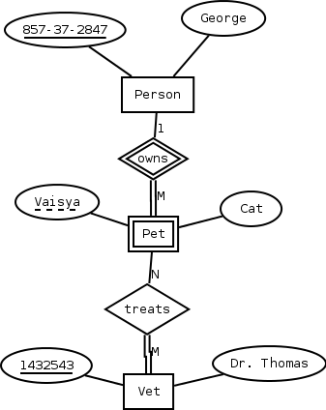

1. Multivalued attributes of a weak entity would be mapped to a separate table with a concatenation of primary and partial key for relational reference.

######################################Exercise A#####################################

EMPLOYEE(employee id, fname, mname, lname)

DEPENDENT(fname, mname, lname, birth_date, insurance)

HOBBY(type, years_involved)

#####################################Exercise B##########################

6.3 A student **may** drive **only one** automobile. **Only one** automobile **may** be driven by a **single** student.

7.5 A person **may** own **many** pets. Each pet **must** have **only one** owner.

**Many** pets **may** be treated the same Vet. A Vet **must** treat **many** pets.